Launch a website on Amazon S3 | AWS Project

Deploying a static website on AWS. This is a beginner-friendly mini AWS project: - Services used: Amazon S3, Amazon Route 53 - Duration: 15-20 minutes - Cost (with free tier): ~$3 USD for custom domain name

Go to Amz Route 53  
Sign up for a domain name using the AR53 service  
ladcze.click (click being the cheapest domain available).

Next  
Go Amz S3 page – create a bucket  
The buck is used to host our website

Type in domain name – ladcze.click  
Select closer region to you (to reduce latency)  
Uncheck “block all public access”. This allows users to access your bucket and poublicly accessible to others via the internet.  
Keep other settings.  
  
Open bucket   
Select upload – navigate to file and select relevant file(s). Clcik upload  
Next, go to properties tab to enable static website (scroll to the bottom)  
Under index doc, type in file name of html uploaded.   
click save changes  
Re permissions – attach a bucket policy  
Next, go to permissions tab  
Add a bucket policy (follow template)

DNS  
  
\*\*Redirect ladcze.click to the S3 bucket - This ensures the bucket is connected to the R53 domain name)

Go to R53  
Hosted zone – create record - choose simple routing policy (if using wizard)   
 – next Define simple record:   
Value: Alias to S3 website endpoint   
choose region – (as with hosted bucket)  
select the s3 endpoint  
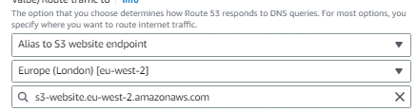  
disable evaluate target health

Summary:  
Created an S3 storage bucket

Uploaded website content

And connect the website to a custom domain name. This enables visitors access the hosted page using the provided weblink.

